CHURCHILL PRIMARY
SCHOOL

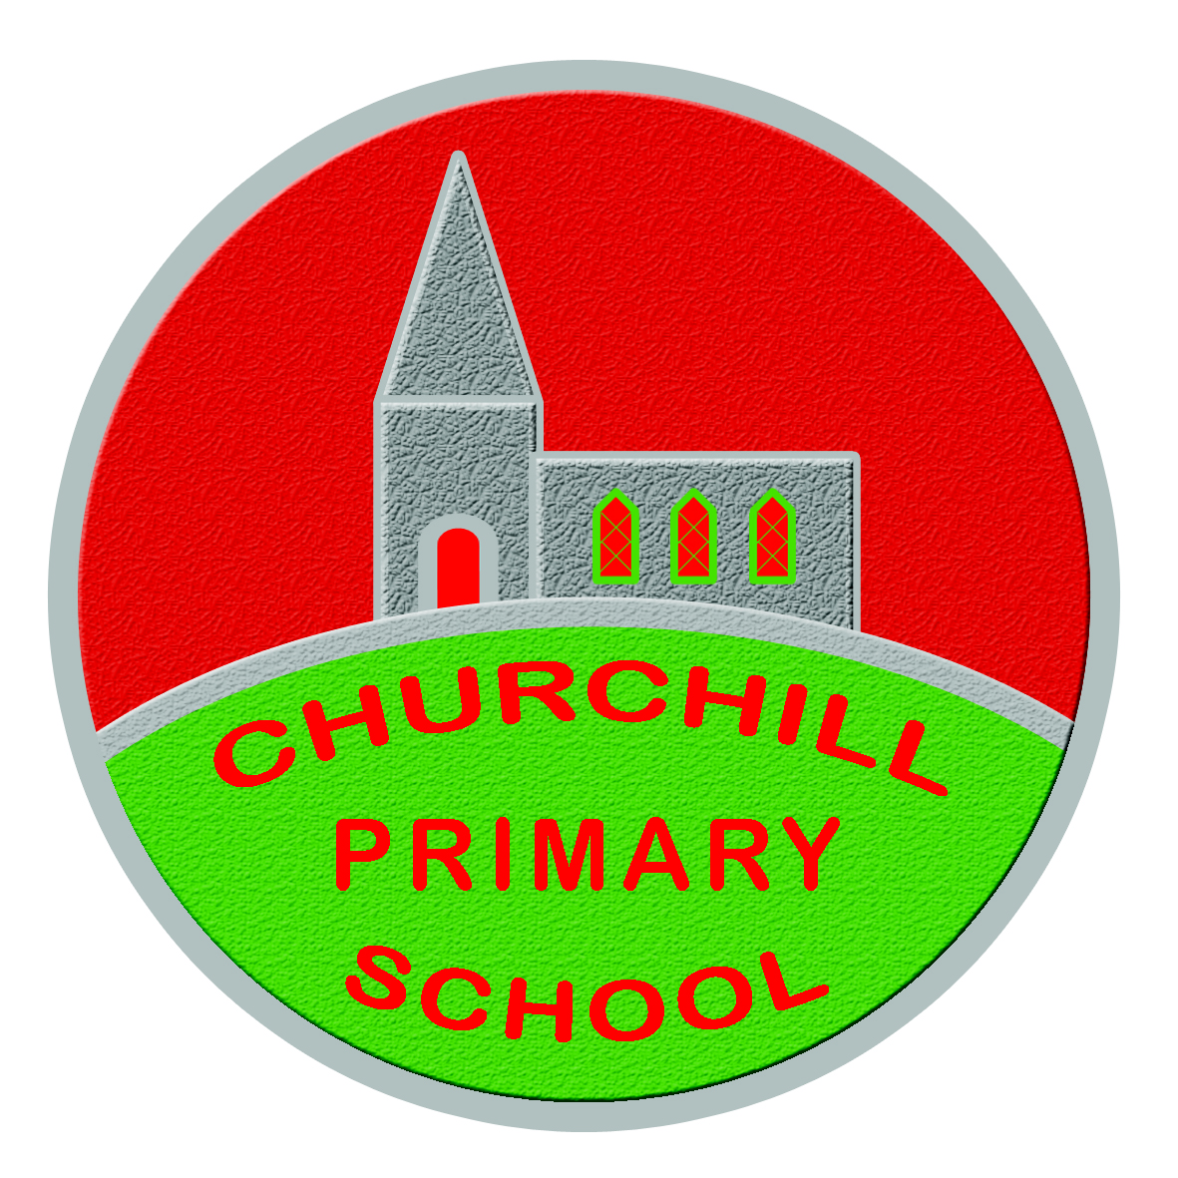

Food in School
POLICY
~ March 2020 ~

FOOD IN SCHOOLS POLICY FOR CHURCHILL PRIMARY SCHOOL

School name: Churchill P.S.

Date of policy implementation: March 2020

Date of next review: March 2021

This school actively supports healthy eating and drinking throughout the school day.

This policy document was produced in consultation with the entire school community, including pupils, parents, school staff, governors, Education Authority representatives, community dietitian and local school nurses.

Aim
To ensure that all aspects of food and nutrition in school promote the health and wellbeing of pupils, staff and visitors to our school.

Objectives

Our objectives are to:
- Review the formal curriculum to ensure information relating to food and nutrition in different lesson areas is consistent and up to date.
- Establish a food week in school to promote healthy eating and drinking messages.
- Ensure that staff who are taking responsibility for food in the classroom have basic food hygiene training.

Action

We will meet our objectives by:
- Discussing at school council.
- Food days in conjunction with school meals - running taster sessions with new recipes.
- Linking with health promoting national events, such as Smile Week for Oral Health, World Cancer Awareness etc.
- Continuing professional development: sending staff in charge of food on a one day basic food hygiene course.
- Parents and pupils will receive regular reminders via text messages, assemblies and school newsletters regarding healthy lunch box items.
- If a child in school has an allergy e.g. nuts, we will take appropriate action following EA and health promotion guidelines e.g. become a nut free school.
- Staff will be trained in using epi pens when the need arises.
- Pupils will be offered milk or water at break and lunch times.
- Healthy snacks (provided by school) will include crackers and cheese; toast with spread; range of chopped fruit on Fridays.

Monitoring and evaluation

We will monitor and evaluate progress through:
- Reporting on progress to the school council and reviewing policy annually in light of improvement and changes.
- Formal curriculum: teachers being able to identify food based topics through schemes of work.
- Food week: principal presenting certificates or prizes in school assembly. Displaying photographs on website/Facebook page/school displays.
- Extra-curricular: cookery club incorporating healthy recipes where reports and photographs posted on the school website/Facebook page.

